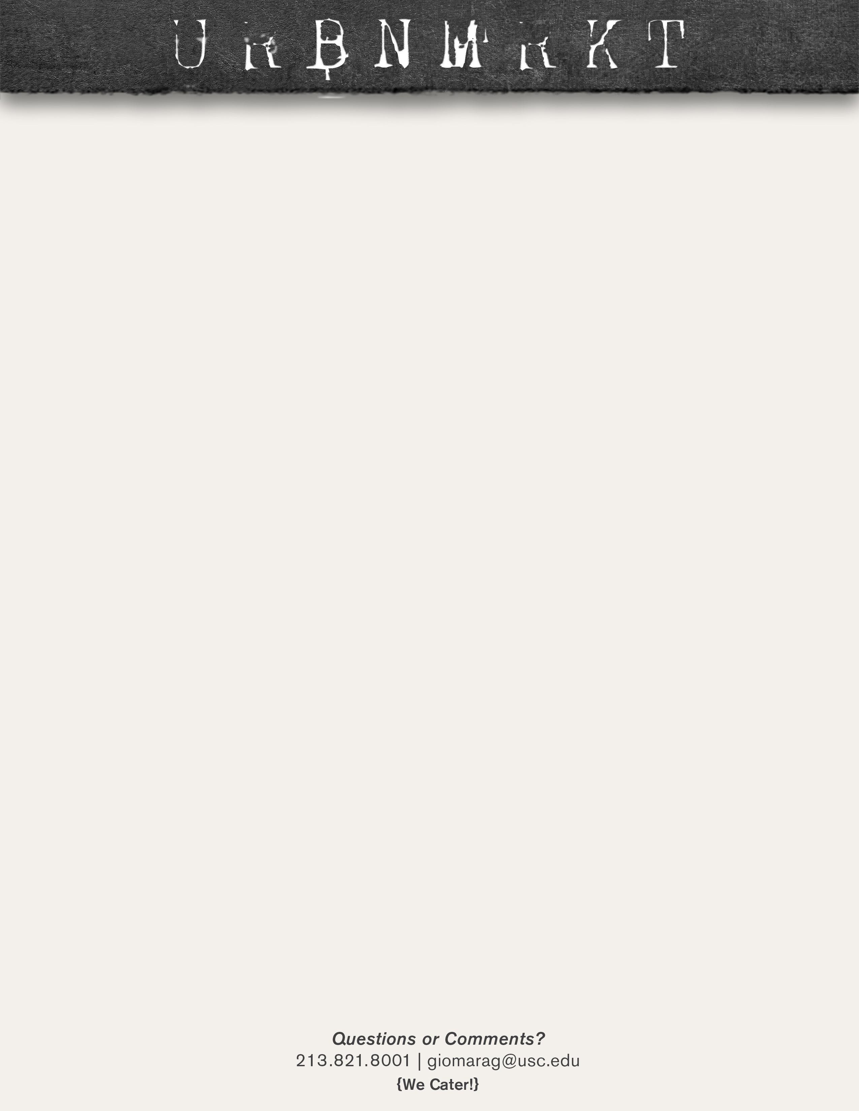

**SOUPS**

**LUNCH**

**SOUPS**

**LUNCH**

**LUNCH**

**SOUPS**

**SOUPS**

**LUNCH**

**August 26-30**

**August 19-23**

**August 12-16**

**August 5- 9**

**African Tea Latte** – African Nectar tea, vanilla, steamed milk

**Bagel Breakfast Sandwich-** with bacon or sausage on a toasted plain bagel and a small orange juice or coffee $4.99

|  |  |  |
| --- | --- | --- |
| **BREAKFAST:**  **COFFEE:** |  |  |
| **MONDAY** | **Pastrami Sandwich-** with French fries and a fountain drink $7.99 | Chicken Enchilada and Tomato Florentine |
| **TUESDAY** | **Taco Tuesday- Carne Asada or Chicken**– 1 for $1.79 or 4 with a fountain drink $7.49 | Split pea and Minestrone |
| **WEDNESDAY** | **Bbq Spare Ribs-** with French fries and a fountain drink $8.99 | Clam Chowder and Seven Bean |
| **THURSDAY** | **Reuben Sandwich-** with French fries and a fountain drink $7.99 | Chicken Tortilla and Butternut Squash |
| **FRIDAY** | **Chicken Enchiladas-** with rice, beans and a fountain drink $7.99 | Chicken Noodle and Broccoli Cheddar |

**Raspberry White Chocolate Mocha** - Espresso, steamed milk, white chocolate, raspberry

**URBN Benedict-** with a small orange juice or coffee $4.99

|  |  |  |
| --- | --- | --- |
| **BREAKFAST:**  **COFFEE:** |  |  |
| **MONDAY** | **Pulled Pork Sandwich-** with French fries and a fountain drink $7.99 | Potato Bacon and Corn Chowder |
| **TUESDAY** | **Ground Beef Spaghetti-** with garlic bread and a fountain drink $7.99 | Chicken and Wild Rice and Potato Leek |
| **WEDNESDAY** | **Baked Half Chicken-** with rice pilaf and veggies, plus a fountain drink $8.99 | Gumbo and Tomato Bisque |
| **THURSDAY** | **Philly Cheese Steak-** with French fries and a fountain drink $7.99 | Italian Wedding and Garden Vegetable |
| **FRIDAY** | **Ground Beef Enchiladas-** with rice, beans and a fountain drink $7.99 | Lobster Bisque and Harvest Mushroom |

|  |  |  |
| --- | --- | --- |
| **BREAKFAST:**  **COFFEE:** |  |  |
| **MONDAY** | **Pastrami Sandwich-** with French fries and a fountain drink $7.99 | Clam Chowder and Tomato Florentine |
| **TUESDAY** | **Taco Tuesday- Carnitas or Chicken**– 1 for $1.79 or 4 with a fountain drink $7.49 | Chicken Tortilla and Minestrone |
| **WEDNESDAY** | **Bbq Spare Ribs-** with French fries and a fountain drink $8.99 | Chicken Noodle and Seven Bean |
| **THURSDAY** | **Reuben Sandwich-** with French fries and a fountain drink $7.99 | Chicken Dumpling and Butternut Squash |
| **FRIDAY** | **Chicken Enchiladas-** with rice, beans and a fountain drink $7.99 | Chili and Broccoli Cheddar |

**French Toast-** with a side of bacon or sausage and a small orange juice or coffee $4.99

**Watermelon Green Iced Tea-** Green tea tropical, watermelon, ice

**Lavender Latter-** espresso, steamed milk, lavender

**Croissant Breakfast Sandwich-** bacon or sausage with a small orange juice or coffee $4.99

|  |  |  |
| --- | --- | --- |
| **BREAKFAST:**  **COFFEE:** |  |  |
| **MONDAY** | **Pulled Pork Sandwich** - Brioche bun served with French fries and a fountain drink $7.99 | Gumbo and Corn Chowder |
| **TUESDAY** | **Ground Beef Spaghetti-** with garlic bread and a fountain drink $7.99 | Italian Wedding and Potato Leek |
| **WEDNESDAY** | **Baked Half Chicken-** with rice pilaf and veggies, plus a fountain drink $8.99 | Lobster Bisque and Tomato Bisque |
| **THURSDAY** | **Philly Cheese Steak-** with French fries and a fountain drink $7.99 | Chicken Enchilada and Garden Vegetable |
| **FRIDAY** | **Ground Beef Enchiladas-** with rice and beans, plus a fountain drink $7.99 | Split Pea and Harvest Mushroom |