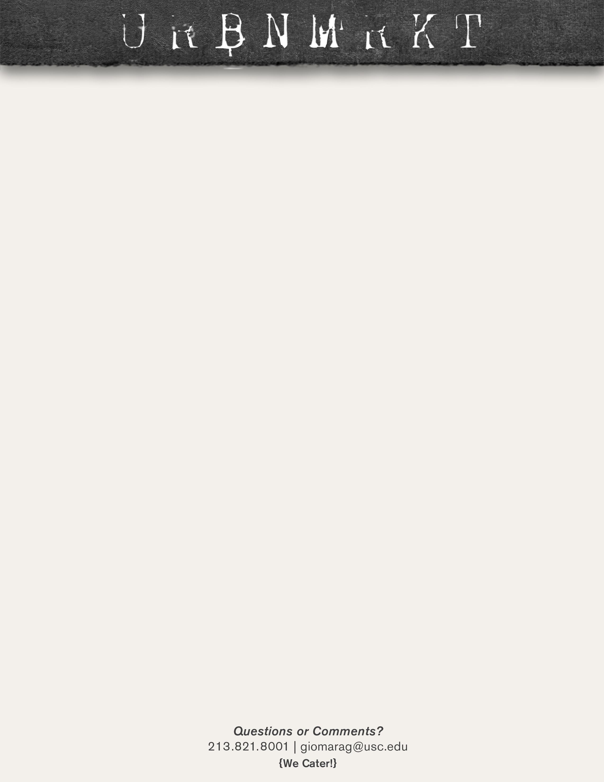

**SOUPS**

**LUNCH**

**SOUPS**

**LUNCH**

**LUNCH**

**SOUPS**

**SOUPS**

**LUNCH**

**FEB 25- 3/1**

**FEB 18-22**

**FEB 11-15**

**FEB 4-8**

**Blackberry Mocha**- espresso, steamed milk, blackberry, cocoa

**Chorizo Breakfast Burrito** with a small orange juice or coffee $4.99

|  |  |  |
| --- | --- | --- |
| **BREAKFAST:**  **COFFEE:** |  |  |
| **MONDAY** | **Pastrami Sandwich** with French fries and a fountain drink $7.99 | Chicken Noodle and Seven Bean |
| **TUESDAY** | **Ground Beef Spaghetti** with garlic bread and a fountain drink $7.99 | Chicken Dumpling and Butternut Squash |
| **WEDNESDAY** | **Asian Style Ribs** with white rice and a fountain drink $8.99 | Chili and Broccoli Cheddar |
| **THURSDAY** | **Reuben Sandwich** with French fries and a fountain drink $7.99 | Bacon Potato and Corn Chowder |
| **FRIDAY** | **Ground Beef Lasagna** with garlic bread and a fountain drink $8.99 | Chicken and Wild Rice and Potato Leek |

**Chocolate Mint Mocha**- espresso, steamed milk, chocolate mint, cocoa

**Bagel Breakfast sandwich**- Eggs, bacon or sausage, cheese on a warm toasted plain bagel and a small orange juice or coffee $4.99

|  |  |  |
| --- | --- | --- |
| **BREAKFAST:**  **COFFEE:** |  |  |
| **MONDAY** | **CLOSED** | **CLOSED** |
| **TUESDAY** | **Taco Tuesday**- Ground Beef or Chicken- 1 for $1.79 or 4 with a fountain drink $7.49 | Chicken Enchilada and Harvest Mushroom |
| **WEDNESDAY** | **Baked Half Chicken** with rice pilaf and veggies, plus a fountain drink $8.99 | Split Pea and Garden Vegetable |
| **THURSDAY** | **Philly Cheese Steak** with French fries and a fountain drink $7.99 | Chicken Tortilla and Tomato Florentine |
| **FRIDAY** | **Blackened Salmon** with rice pilaf and corn on the cobb, plus a fountain drink $8.99 | Clam Chowder and Minestrone |

|  |  |  |
| --- | --- | --- |
| **BREAKFAST:**  **COFFEE:** |  |  |
| **MONDAY** | **Bbq Pulled Pork** sandwich with French fries and a fountain drink $7.99 | Bacon Potato and Butternut Squash |
| **TUESDAY** | **Chicken Spaghetti** with garlic bread and a fountain drink $7.99 | Chicken and Wild rice and Broccoli Cheddar |
| **WEDNESDAY** | **Bbq Spare Ribs** with French fries and a fountain drink $8.99 | Gumbo and Corn Chowder |
| **THURSDAY** | **Reuben Sandwich** with French fries and a fountain drink $7.99 | Italian Wedding and Potato Leek |
| **FRIDAY** | **Chicken Enchiladas** with rice, beans and a fountain drink $7.99 | Lobster Bisque and Tomato Bisque |

|  |  |
| --- | --- |
| **URBN Breakfast**- eggs, potatoes, bacon or sausage, 2 pancakes and a small orange juice or coffee $6.99 | |
| Beverage special- Coconut latte- espresso, steamed milk, coconut |

**Coconut Latte**- espresso, steamed milk, coconut, vanilla

**Caramel Macchiato-** Espresso, steamed milk, vanilla, caramel

**URBN Benedict-** Eggs your way, tomato, bacon, avocado, and cheese on a warm English muffin, with a small orange juice or coffee $4.99

|  |  |  |
| --- | --- | --- |
| **BREAKFAST:**  **COFFEE:** |  |  |
| **MONDAY** | **Pastrami Sandwich** with French fries and a fountain drink $7.99 | Clam Chowder and Garden Vegetable |
| **TUESDAY** | **Taco Tuesday**- Carne Asada or Chicken- 1 or $1.79 or 4 with a fountain drink $7.49 | Chicken Tortilla and Harvest Mushroom |
| **WEDNESDAY** | **Baked Half Chicken** with rice pilaf and veggies, plus a fountain drink $8.99 | Chicken Noodle and Tomato Florentine |
| **THURSDAY** | **Philly Cheese Steak** with French fries and a fountain drink $7.99 | Chicken Dumpling and Minestrone |
| **FRIDAY** | **Blackened Salmon** with rice pilaf and corn on the cobb $8.99 | Chili and Seven bean |