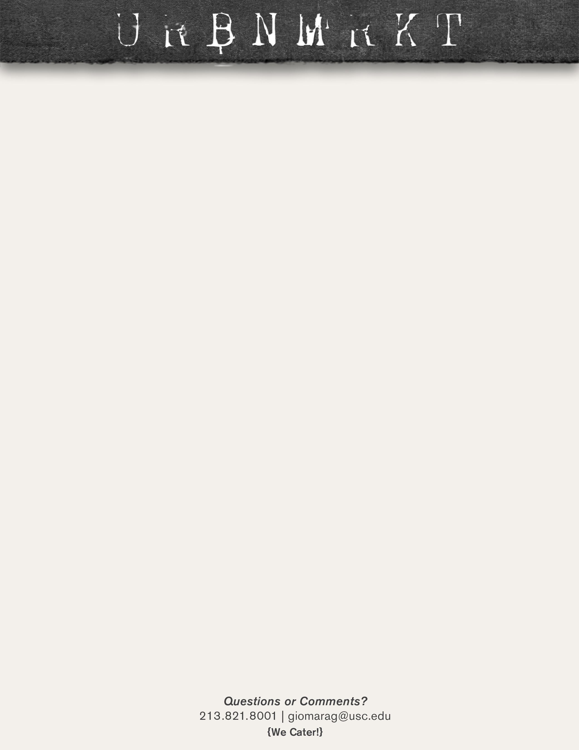

**SOUPS**

**LUNCH**

**SOUPS**

**LUNCH**

**LUNCH**

**SOUPS**

**SOUPS**

**LUNCH**

**March 23-27**

**March 16-20**

**March 9-13**

**March 2-6**

**Lavender Oat Milk Latte-** Espresso, steamed oat milk, vanilla, and lavender

**Pancakes-** with a side of bacon or sausage and a small orange juice or coffee $4.99

|  |  |  |
| --- | --- | --- |
| **BREAKFAST:**  **COFFEE:** |  |  |
| **MONDAY** | **Pulled Pork Sandwich-** with French fries and a fountain drink $7.99 | Split Pea and Tomato Bisque |
| **TUESDAY** | **Beef and Broccoli-** with white rice, a fried egg roll and a fountain drink $8.99 | Chicken Dumpling and Harvest Mushroom |
| **WEDNESDAY** | **Baked Half Chicken-** with rice pilaf, veggies and a fountain drink $8.99 | Gumbo and Corn Chowder |
| **THURSDAY** | **Philly Cheese Steak-** with French fries and a fountain drink $7.99 | Chili and Garden Vegetable |
| **FRIDAY** | **Ground Beef Lasagna-** with garlic bread and a fountain drink $8.99 | Chicken Noodle and Broccoli Cheddar |

**Peach Green Tea Lemonade-** Iced tropical green tea, peach, and lemonade

**Biscuits and Gravy-** with bacon or sausage a small orange juice or coffee $5.99

|  |  |  |
| --- | --- | --- |
| **BREAKFAST:**  **COFFEE:** |  |  |
| **MONDAY** | **Pastrami Sandwich-** with French fries and a fountain drink $7.99 | Potato Bacon and Seven Bean |
| **TUESDAY** | **Ground Beef Spaghetti-** with garlic bread and a fountain drink $7.99 | Chicken Tortilla and Potato Leek |
| **WEDNESDAY** | **Bbq Spare Ribs-** with French fries and a fountain drink $8.99 | Lobster Bisque and Butternut Squash |
| **THURSDAY** | **Reuben Sandwich-** with French fries and a fountain drink $7.99 | Italian Wedding and Tomato Florentine |
| **FRIDAY** | **Herb Blackened Salmon-** with rice pilaf, veggies and a fountain drink $8.99 | Chicken Enchilada and Minestrone |

|  |  |  |
| --- | --- | --- |
| **BREAKFAST:**  **COFFEE:** |  |  |
| **MONDAY** | **Pulled Pork Sandwich-** with French fries and a fountain drink $7.99 | Gumbo and Tomato Bisque |
| **TUESDAY** | **Beef and Broccoli-** with white rice, a fried egg roll and a fountain drink $8.99 | Chili and Harvest Mushroom |
| **WEDNESDAY** | **Baked Half Chicken-**  with rice pilaf and veggies, plus a fountain drink $8.99 | Chicken Noodle and Corn Chowder |
| **THURSDAY** | **Philly Cheese Steak-** with French fries and a fountain drink $7.99 | Chicken and Wild Rice and Garden Vegetable |
| **FRIDAY** | **Ground Beef Lasagna-** with garlic bread and a fountain drink $8.99 | Clam Chowder and Broccoli and Cheddar |

**URBN Benedict-** with bacon or sausage and a small orange juice or coffee $5.99

**Irish Cream Latte-** Espresso, steamed milk, Irish cream, vanilla

**Hibiscus Blueberry Lemonade-** Hibiscus iced tea, blueberry, and lemonade

**French Toast-** with a side of bacon or sausage and a small orange juice or coffee $4.99

|  |  |  |
| --- | --- | --- |
| **BREAKFAST:**  **COFFEE:** |  |  |
| **MONDAY** | **Pastrami Sandwich-** with French fries and a fountain drink $7.99 | Lobster Bisque and Seven Bean |
| **TUESDAY** | **Ground Beef Spaghetti-** with garlic bread and a fountain drink $7.99 | Italian Wedding and Potato Leek |
| **WEDNESDAY** | **Bbq Spare Ribs-** with French fries and a fountain drink $8.99 | Chicken Enchilada and Butternut Squash |
| **THURSDAY** | **Reuben Sandwich-** with French fries and a fountain drink $7.99 | Split Pea and Ham and Tomato Florentine |
| **FRIDAY** | **Herb Blackened Salmon-** with rice pilaf, veggies and a fountain drink $8.99 | Chicken Dumpling and Minestrone |